Chapter 7. Constructors
The main purpose of constructors is to set the initial state of an object when the object is created by using the new operator.
Constructor declarations are very much like method declarations. However, the following restrictions on constructors should be noted:
- Modifiers other than an accessibility modifier are not permitted in the constructor header.
- Constructors cannot return a value and, hence, cannot specify a return type, not even void, in the constructor header, but they can contain the simple form of the return statement in the constructor body.
- Constructor name must be the same as the class name.
- Constructor can’t be inherited and overridden.
- Constructor can’t be recursive.
Class names and method names exist in different namespaces. Thus, there are no name conflicts in Example, where a method declared at (2) has the same name as the constructor declared at (1). However, using such naming schemes is strongly discouraged.

Example 4.5 Namespaces
public class Name {

Name() { // (1)
System.out.println("Constructor");
}

void Name() { // (2)
System.out.println("Method");
}
public static void main(String[] args) {
new Name().Name(); // (3) Constructor call followed by method call.
}
}
Output from the program:
Constructor
Method

Default Constructor
A default constructor is a constructor without any parameters. In other words, it has the following signature:
<class name>()
This type of constructor takes no arguments and it is called when object are created without any explicit initialization.
Construct m1=new Construct();
If a class does not specify any constructors, then an implicit default constructor is supplied for the class. For e.g.

In the following code, the class Light does not specify any constructors.
class Light {
// Fields
int noOfWatts; // wattage
boolean indicator; // on or off
String location; // placement

// No constructors
//...
}

class Greenhouse {
// ...
Light oneLight = new Light(); // (1) Call of implicit default constructor.
}
Creating an object using the new operator with the implicit default constructor, as at (1), will initialize the fields of the object to their default values (i.e., the fields noOfWatts, indicator, and location in a Light object will be initialized to 0, false, and null, respectively).
A class can choose to provide an implementation of the default constructor. In the following example, the class Light provides an explicit default constructor at (1). Note that it has the same name as the class, and that it does not take any parameters.
class Light {
// Fields
int noOfWatts; // wattage
boolean indicator; // on or off
String location; // placement

// Explicit Default Constructor
Light() { // (1)
noOfWatts = 50;
indicator = true;
location = "X";
}
//...
}

class Greenhouse {
// ...
Light extraLight = new Light(); // (2) Call of explicit default constructor.
}
The explicit default constructor ensures that any object created with the expression new Light(), as at (2), will have its fields noOfWatts, indicator and location initialized to 50, true and "X", respectively.
Parameterized Constructor

This type of constructor is called when an object is created and it is initialized at the time of creation. For e.g.

Construct m1=new Construct(100,5000);
If a class defines any explicit constructors, it can no longer rely on the implicit default constructor to set the state of the objects. If such a class requires a default constructor, its implementation must be provided. In the example below, class Light only provides a non-default constructor at (1). It is called at (2) when an object of class Light is created with the new operator. Any attempt to call the default constructor will be flagged as a compile time error as shown at (3).
In Java, this is a keyword that refers to the current object (the object that is currently calling the method or constructor).
class Light {
int noOfWatts; // wattage
boolean indicator; // on or off
String location; // placement
// Only non-default Constructor
Light(int noOfWatts, boolean indicator, String location) { // (1)
this.noOfWatts = noOfWatts;
this.indicator = indicator;
this.location = location;
}
//...
}
class Greenhouse {
// ...
Light moreLight = new Light(100, true, "Greenhouse"); // (2) OK.
// Light firstLight = new Light(); // (3) Compile time error.
}

Copy Constructor

This type of constructor is called when an object is created and it is initialized with the other object of the same class at the time of creation.

Construct m2=new Construct(m2);

class Construct
{
private String name="";
private int age;
private int salary;
public Construct()
{
name="";
age=salary=0;
}
public Construct(String name, int age, int salary)
{
this.name=name;
this.age=age;
this.salary=salary;
}
public Construct(Construct obj)
{
name=obj.name);
age=obj.age;
salary=obj.salary;
}
public void show()
{
System.out.println(name+"\t"+age+"\t"+salary);
}
}

import java.io.*;
class Useconstruct
{ public static void main(String args[])
{
Construct obj1=new Construct(); //Default constructor
obj1.show();

Construct obj2=new Construct("amit",26,5000); //parameteried
obj2.show();

Construct obj3=new Construct(obj2); //copy
obj3.show();

obj2.set("java",28,6000);
obj2.show();
}
}

Overloaded Constructors
Like methods, constructors can also be overloaded. Since the constructors in a class all have the same name as the class, their signatures are differentiated by their parameter lists
class Light {
// Fields
int noOfWatts; // wattage
boolean indicator; // on or off
String location; // placement

// Explicit Default Constructor
Light() {
noOfWatts = 50;
indicator = true;
location = "X";
}

// Non-default Constructor
Light(int noOfWatts, boolean indicator, String location) {
this.noOfWatts = noOfWatts;
this.indicator = indicator;
this.location = location;
}
public void show(){
System.out.println(noOfWatts+"\t"+indicator+"\t"+location);
}
//...
}

class Greenhouse {
public static void main(String a[]){
Light moreLight = new Light(100, true, "Greenhouse"); // (3) OK.
Light firstLight = new Light(); // (4) OK.
firstLight.show();
moreLight.show();}
}

A private constructor and a Singleton class

A Singleton class allows only one object to exist throughout the application.

A Singleton class must have a private constructor.

Private Constructor
↓
Prevents object creation using new
↓
Singleton creates one object internally
↓
Provides that object through getInstance()

class Database {

// Single object
private static Database obj = null;

// Private constructor
private Database() {
System.out.println("Database Created");
}

// Public method to access the object
public static Database getInstance() {
if(obj == null){
obj = new Database();
}
return obj;
}
}

public class Test {

public static void main(String[] args) {

Database d1 = Database.getInstance();
Database d2 = Database.getInstance();

System.out.println(d1 == d2);
}
}

the Singleton Design Pattern. The main idea is:
- Only one object of the Database class can be created.
- Every call to getInstance() returns the same object.

Step 1: Class Loading
When the program starts, the Database class is loaded.

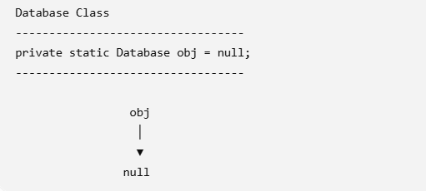

Step 2: First Call

Database d1 = Database.getInstance();

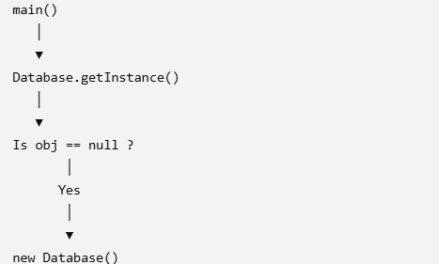

A new object is created.

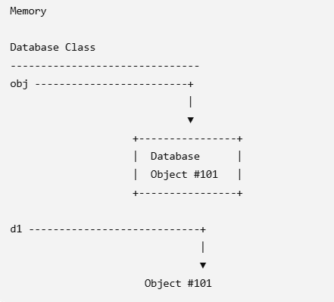

Constructor Output:
Database Created

This message appears only once.

Step 3: Second Call

Database d2 = Database.getInstance();

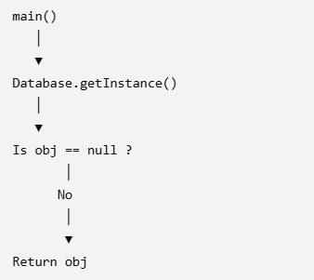

Since obj already stores the object reference, no new object is created.

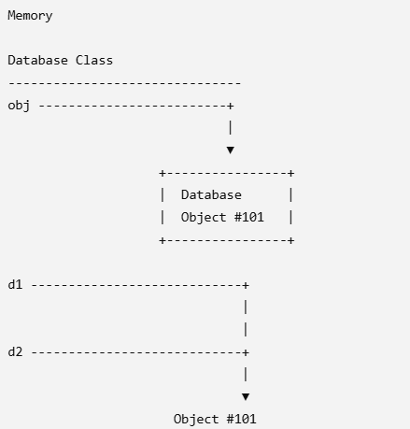

Notice that d1, d2, and obj all point to the same object.

Why d1 == d2 is true
Suppose the object address is #101.

d1 ---------> Address #101
d2 ---------> Address #101

In Java, Initializer Blocks are blocks of code that execute automatically when an object is created or when a class is loaded.
There are two types of initializer blocks:
- Instance Initializer Block (IIB)
- Static Initializer Block (SIB) (You wrote "attic", but I think you meant "static".)

1. Instance Initializer Block (IIB)
Definition
An Instance Initializer Block is a block of code without the static keyword.
- It executes every time an object is created.
- It executes before the constructor.
- It is used to initialize instance variables with common code shared by all constructors.

class Student {
{
System.out.println("Instance Initializer Block");
}

Student() {
System.out.println("Constructor");
}

public static void main(String[] args) {

Student s1 = new Student();

System.out.println();

Student s2 = new Student();
}
}

Use Case of Instance Initializer Block
Suppose every employee should automatically receive an Employee ID whenever an object is created.
Instead of writing the same code in every constructor, write it once in the initializer block.

class Employee {

static int nextId = 1001;

int empId;

{
empId = nextId++;
}

Employee() {
}

Employee(String name) {
}

void display() {
System.out.println("Employee ID = " + empId);
}

public static void main(String[] args) {

Employee e1 = new Employee();
Employee e2 = new Employee("Rahul");
Employee e3 = new Employee();

e1.display();
e2.display();
e3.display();
}
}

Static Initializer Block (SIB)
Definition
A Static Initializer Block is an initializer block declared with the static keyword.
- It executes only once.
- It executes when the class is loaded into memory, before main() runs.
- It is used to initialize static variables or perform one-time setup.

class Student {

static {
System.out.println("Static Initializer Block");
}

Student() {
System.out.println("Constructor");
}

public static void main(String[] args) {

Student s1 = new Student();
Student s2 = new Student();
}
}

Use Case of Static Initializer Block
Suppose your application needs to load configuration only once.

class Database {

static String url;

static {

url = "jdbc:mysql://localhost:3306/mydb";
}

public static void main(String[] args) {

System.out.println(url);
}
}

